
PRESS RELEASE Ostrava, 14t^{h} June 2017

Breakfast with Antonín Panenka and Karol Dobiaš in Nová Karolina Park

One Wednesday morning in May, PASSERINVEST GROUP pleasantly surprised the tenants and employees of the Nová Karolina Park building, its office project in the centre of Ostrava. At the receptions of both parts of the building breakfast awaited them in the form of homemade Moravian tarts and stuffed croissants, coffee, tea and a surprise, specifically football legends Antonín Panenka and Karol Dobiaš, who handed out autographs on signature cards, jerseys and posters, and took photos and held lively conversations with those who came.

Nová Karolina Park, an office building from the leading Czech developer and investor PASSERINVEST GROUP, joins the historic centre and the modern area of the city of Ostrava. There are currently 800 people working in the building’s offices, and 600 people took part in the breakfast that day. The event was a small gift from the developer and manager of the building to make the
mid-week working day more pleasant, while commemorating the company’s important milestone. This year PASSERINVEST Group is celebrating its 25th anniversary from its founding and it will be celebrating this landmark throughout the course of the entire year with small events as well as a large celebration that will be taking place at the end of June in the company’s headquarters, in BB Centrum in Prague 4.
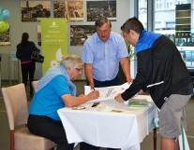

From left: Karol Dobiaš and Antonín Panenka during the autograph session in Nová Karolina Park

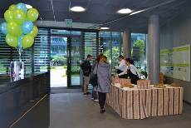

Breakfast prepared for the tenants and employees of Nová Karolina Park

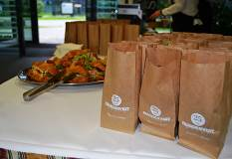

Breakfast prepared for the tenants and employees of Nová Karolina Park

ABOUT THE NOVÁ KAROLINA PARK PROJECT
The Nová Karolina Park office building is sensitively located in a newly-urbanised area of Ostrava near Masarykovo náměstí and it forms a “gateway” from the historic core of the city. The developer of the project is a joint venture between PASSERINVEST GROUP and GEMO OLOMOUC. The project’s architectural design comes from the drawing boards of Vít Máslo and David R. Chisholm of CMC architects. The entire project is spread out over 32 hectares of space on six storeys and it offers almost 24,600 m² of prime office space. This is supplemented on the ground floor with 3700 m² of space suitable for shops, services and restaurants. There are 279 underground parking spaces meant for the users of the building. Nová Karolina Park is certified as a green building according to BREEAM (BRE Environmental Assessment Method). The British BREEAM certificate is a prestigious methodology for the certification of green buildings in Europe.

PASSERINVEST GROUP, a. s., is a purely Czech development company, whose name is primarily connected with the construction of the multifunctional BB Centrum complex in Prague 4 – Michle. The company, founded in 1991 by Radim Passer, built a very good name on both a domestic and international level with this, the most successful and extensive Czech project of its kind. This is not only due to the quality of the implemented projects and the high level of provided services, but also to a sense of fair play, an accommodating relationship with the tenants/users of the buildings and the responsibility towards society and the environment. PASSERINVEST GROUP also has other interesting development projects in its portfolio.

For more information and photographs in print quality please contact:
Kristýna Samková, Head of PR and Marketing dept.
PASSERINVEST GROUP, a.s.
Tel.: (+420) 221 582 111
Mobil: (+420) 602 186 708
E-mail: Kristyna.Samkova@Passerinvest.cz
www.passerinvest.cz, www.bbcentrum.cz

Marcela Štefcová
Crest Communications a.s.
Mobile: (+420) 731 613 669
E-mail: marcela.stefcova@crestcom.cz
www.crestcom.cz

